https://unsplash.com/photos/ETRPjvb0KM0
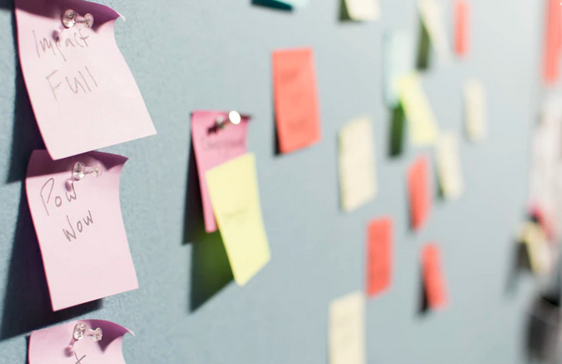
https://unsplash.com/photos/KigTvXqetXA
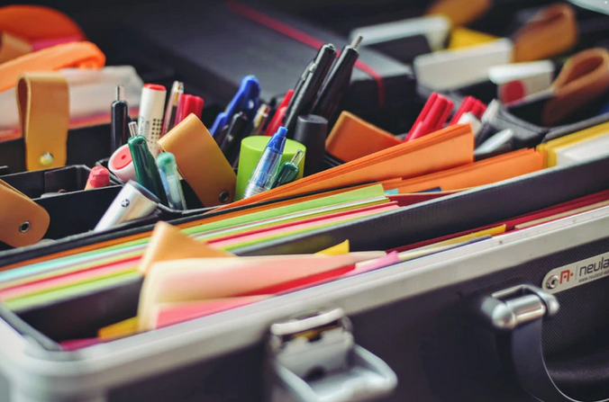

https://unsplash.com/photos/KdeqA3aTnBY
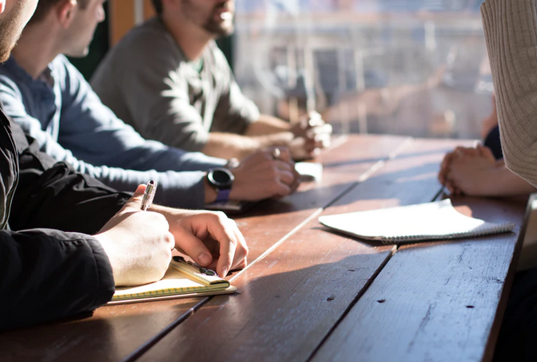
https://unsplash.com/photos/Hcfwew744z4

https://unsplash.com/photos/ESClFkgWwH8
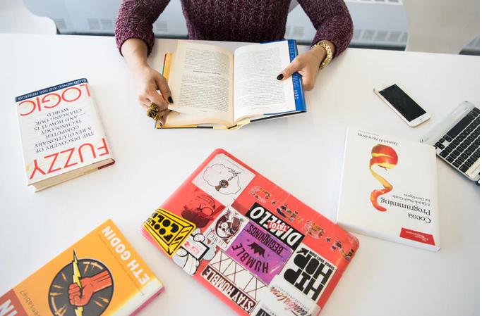
https://unsplash.com/photos/IOzk8YKDhYg
https://unsplash.com/photos/5QgIuuBxKwM

